# **Tableau Project Documentation**

## **1. Project Overview**

### **1.1 Project Title**

Amazon Sales and Logistic Performance.

### **1.2 Objective**

The project aims to analyze Amazon order delivery performance, order fulfillment efficiency, and customer behavior to optimize logistics and reduce late deliveries and cancellations.

### **1.3 Scope**

KPIs:

Total Orders

Total Revenue

Late Delivery Rate

On-Time Delivery Rate

Cancellation Rate

Average Order Value

### **1.4 Timeline**

Provide an estimated timeline for different phases of the project, such as data collection, cleaning, modeling, visualization, and final review.

|  |  |  |
| --- | --- | --- |
| **Phase** | **Description** | **Estimated Duration** |
| Data Collection | Gathering relevant datasets | 1 days |
| Data Cleaning | Handling missing values, removing duplicates | 2 days |
| Data Modeling | Defining relationships, creating measures | 0 days |
| Visualization | Designing dashboard and visual elements | 2 days |
| Final Review | Testing and refining dashboard | 1 days |

## **2. Data Collection & Preparation**

### **2.1 Data Sources**

Used Kaggle dataset of Amazon sales .The dataset contains **128,942** records and **14 columns** related to Amazon order fulfillment, shipping, and sales.

### **2.2 Data Cleaning & Transformation**

Identifying Missing Data**:**Used Power Query’s "Column Profile" and "ColumnDistribution"tools to detect null values.

### **Removing Duplicates : Checked for duplicate orders based on** Order ID, Order Date.

Ensured all numerical fields were in the correct data type (integer, decimal).

Removed unused columns to improve performance.

## **3. Dashboard Development**

### **3.1 Mockup Designs**

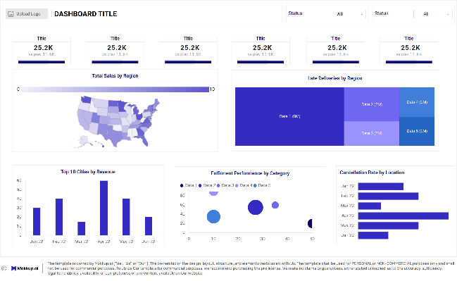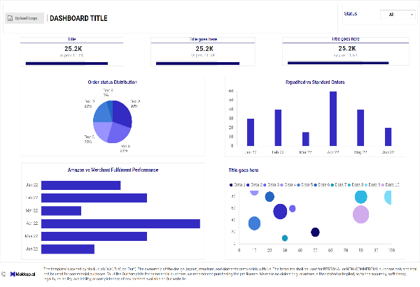

### **3.2 Key Visualizations**

**KPIs Used:**

* **Distinct Count of Order ID:** Total number of unique orders.
* **Total Sales Amount:** Sum of all orders processed.
* **Average Order Value (AOV):** (Total Sales Amount / Number of Orders), showing how much customers spend per order.
* **Late Delivery Rate:** (Late Deliveries / Total Deliveries) * 100, measuring shipping delays.
* **On-Time Delivery Rate:** (On-Time Deliveries / Total Deliveries) * 100, showing delivery efficiency.
* **Cancellation Rate:** (Cancelled Orders / Total Orders) * 100, tracking order cancellations.

**Amazon Order Fulfillment & Performance Overview (Dashboard1):**

#### **a)Order Status Distribution (Pie Chart)**

* **Purpose:** Displays the proportion of orders that are **Shipped, Delivered, Cancelled, Returned, or Pending.**

#### **b) Expedited Orders vs. Standard Orders (Square Chart)**

* **Purpose:** Shows the proportion of expedited vs. standard orders.

#### **c) Amazon vs. Merchant Fulfillment Performance (Bar Chart)**

* **Purpose:** Compares orders fulfilled by **Amazon** vs. **third-party merchants.**

#### **d) B2B vs. B2C Orders (Bubble Chart)**

* **Purpose:** Shows the proportion of Business-to-Business (B2B) vs. Business-to-Consumer (B2C) sales.

**Amazon Logistics & Sales Performance (Dashboard2):**

#### **a) Total Sales by Region (Map)**

* **Purpose:** Visualizes total sales across different regions (states) using color intensity.

#### **b) Late Deliveries by Region (Treemap)**

* **Purpose:** Highlights regions with the highest percentage of late deliveries.

#### **c) Top 10 Cities by Order Volume/ Revenue (Bar Chart)**

* **Purpose:** Displays the highest order and revenue generating cities.

#### **d) Cancellation Rate by Location (Bar Chart)**

* **Purpose:** Highlights regions with the highest order cancellations.

#### **e) Fulfillment Performance by Category (Bubble Chart)**

* **Purpose:** Displays fulfillment success rates across product categories.

### **3.3 Measures and Calculations**

* **Distinct Count of Order ID:** Total number of unique orders.
* **Total Sales Amount:** Sum of all orders processed.
* **Average Order Value (AOV):** (Total Sales Amount / Number of Orders), showing how much customers spend per order.
* **Late Delivery Rate:** (Late Deliveries / Total Deliveries) * 100, measuring shipping delays.
* **On-Time Delivery Rate:** (On-Time Deliveries / Total Deliveries) * 100, showing delivery efficiency.
* **Cancellation Rate:** (Cancelled Orders / Total Orders) * 100, tracking order cancellations.

### **3.4 Filters and Slicers**

Used Fulfilment Slicer in Amazon Order Fulfillment & Performance Overview view and category filter in Amazon Logistics & Sales Performance.

## **4. Insights & Findings**

### **Expedited vs. Standard Orders**

* **Expedited Orders:** 68.89% of total orders, preferred by customers.
* **Standard Orders:** 31.11%, which might be contributing to late deliveries.
* **Actionable Insight:** Expand **expedited shipping options** or incentivize customers to opt for faster deliveries.

### **Fulfillment Performance: Amazon vs. Merchant**

* **Amazon Fulfillment:** 69.78% of orders, more efficient.
* **Merchant Fulfillment:** 30.22% of orders, likely facing logistical issues.
* **Decision-Making Impact:** Consider shifting more fulfillment to **Amazon warehouses** for better efficiency or supporting merchants with logistics improvements.

### **B2B vs. B2C Market Segmentation**

* **B2C Orders Dominate:** **99.15% of total sales** come from B2C customers.
* **B2B Market Is Underutilized:** Less than **1%** of sales come from B2B.
* **Decision-Making Impact:** Explore **B2B growth opportunities** through partnerships, bulk discounts, and corporate deals.

Sales Performance & Revenue Trends

* **Total Sales:** ₹78.57 million with an average order value of ₹653.
* **Top Cities by Orders:**
  + **Bengaluru (11,096 orders)** is the highest contributor, followed by Hyderabad and Mumbai.
  + **Actionable Insight:** Focus marketing efforts and inventory stocking in top-performing cities.
* **Top-Selling Regions:**
  + States like **Maharashtra, Karnataka, and Tamil Nadu** contribute significantly to total revenue.
  + **Decision-Making Impact:** Optimize supply chain logistics in high-demand areas to improve efficiency.

### **Late Deliveries & Logistics Efficiency**

* **Overall Late Delivery Rate:** **3.07%** (Mostly in Northeastern states and Union Territories).
* **Worst-Affected Regions:**
  + **Mizoram (25%), Ladakh (14.29%), and Puducherry (14.46%)** have the highest late deliveries.
  + **Actionable Insight:** Improve courier efficiency, collaborate with better delivery partners, or establish regional warehouses.

### **Order Cancellations & Returns**

* **Cancellation Rate:** **14.21%**, highest in Rajasthan (33.33%) and Lakshadweep (25%).
* **Reasons for High Cancellations:**
  + Possible **delivery delays**, **stock unavailability**, or **customer dissatisfaction**.
  + **Actionable Insight:** Investigate cancellation reasons and implement proactive customer engagement strategies.

## **5. Challenges & Limitations**

* My dataset contains a date field with only one unique date, limiting time-based analysis.
* Tableau's interface is more complex compared to Power BI.

## **6. Future Enhancements**

* Incorporate historical data to enable trend analysis and time-based comparisons.
* Optimize chart types to enhance readability and ensure insights are conveyed effectively.
* Add tooltips and annotations to provide context and explanations for key metrics.

## **7. Conclusion**

This project provides **actionable insights** into order fulfillment, sales performance, and logistics efficiency, helping businesses optimize operations and improve customer satisfaction.

* **Late Deliveries & Logistics Challenges** 
  + Identified regions with high late delivery rates (e.g., Mizoram, Ladakh).
  + Recommended better courier partnerships and regional fulfillment centers to reduce delays.
* **High Cancellation & Return Rates** 
  + Analyzed cancellation trends, revealing issues in Rajasthan and Lakshadweep.
  + Suggested stock optimization and customer engagement strategies to minimize cancellations.
* **Optimizing Fulfillment: Amazon vs. Merchant** 
  + Found that Amazon-fulfilled orders are more efficient than merchant-fulfilled ones.
  + Recommended shifting more fulfillment to Amazon or improving merchant logistics.
* **Sales & Customer Insights** 
  + Highlighted top-performing regions and customer trends.
  + Suggested expanding **B2B sales**, as it remains an underutilized market opportunity.
* **Improved Decision-Making Through Data Visualization** 
  + Provided interactive dashboards for real-time tracking of orders, cancellations, and fulfillment performance.
  + Enabled stakeholders to filter and drill down into critical business areas for targeted improvements.